Palm Beach County's Unemployment Rate Outpaces State and Nation in Employment Stability

West Palm Beach, Fla. (April 18, 2024) – CareerSource Palm Beach County and FloridaCommerce report that the region's unemployment rate stood at 3.4% in March 2025, positioning it favorably below both the Florida state average of 3.6% and the national rate of 4.2%. ​

Despite a slight increase from 3.0% in March 2024, the county's labor market demonstrates resilience amid broader economic uncertainties. The labor force numbered 778,376, with 26,680 residents unemployed.​

Nonagricultural employment in Palm Beach County reached 707,600, reflecting a year-over-year gain of 1,900 jobs (+0.3%). Notably, the Education and Health Services sector expanded by 5,500 jobs (+4.7%), and Government employment increased by 1,800 jobs (+2.8%), both surpassing statewide growth rates.​

"Palm Beach County's labor market continues to show strength, maintaining unemployment rates below state and national levels," said Julia Dattolo, President and CEO of CareerSource Palm Beach County. "Our focus remains on connecting job seekers with opportunities in our growing industries."​

For more information and resources, visit www.careersourcepbc.com.

Industry | Change | Total Jobs
Education/health services | +5,500 jobs | 123,400
Government | +1,800 jobs | 66,900
Trade/transportation/utilities | +600 jobs | 23,000
Information | -800 jobs | 11,600
Professional Business Services | -2,400 jobs | 131,200
Leisure and hospitality | -3,000 jobs | 97,700

Julia Dattolo, President & CEO of CareerSource Palm Beach County, Honored with Women in Leadership Award
CareerSource Palm Beach County is proud to announce that Julia Dattolo, President and EO, has been recognized with the prestigious Women in Leadership Award in the Nonprofit Sector by the Executive Women of the Palm Beaches Foundation.
This distinguished honor celebrates Julia’s outstanding leadership, dedication, and impactful work within the nonprofit community. Under her guidance, CareerSource Palm Beach County has continued to drive workforce development and economic opportunity across the region.

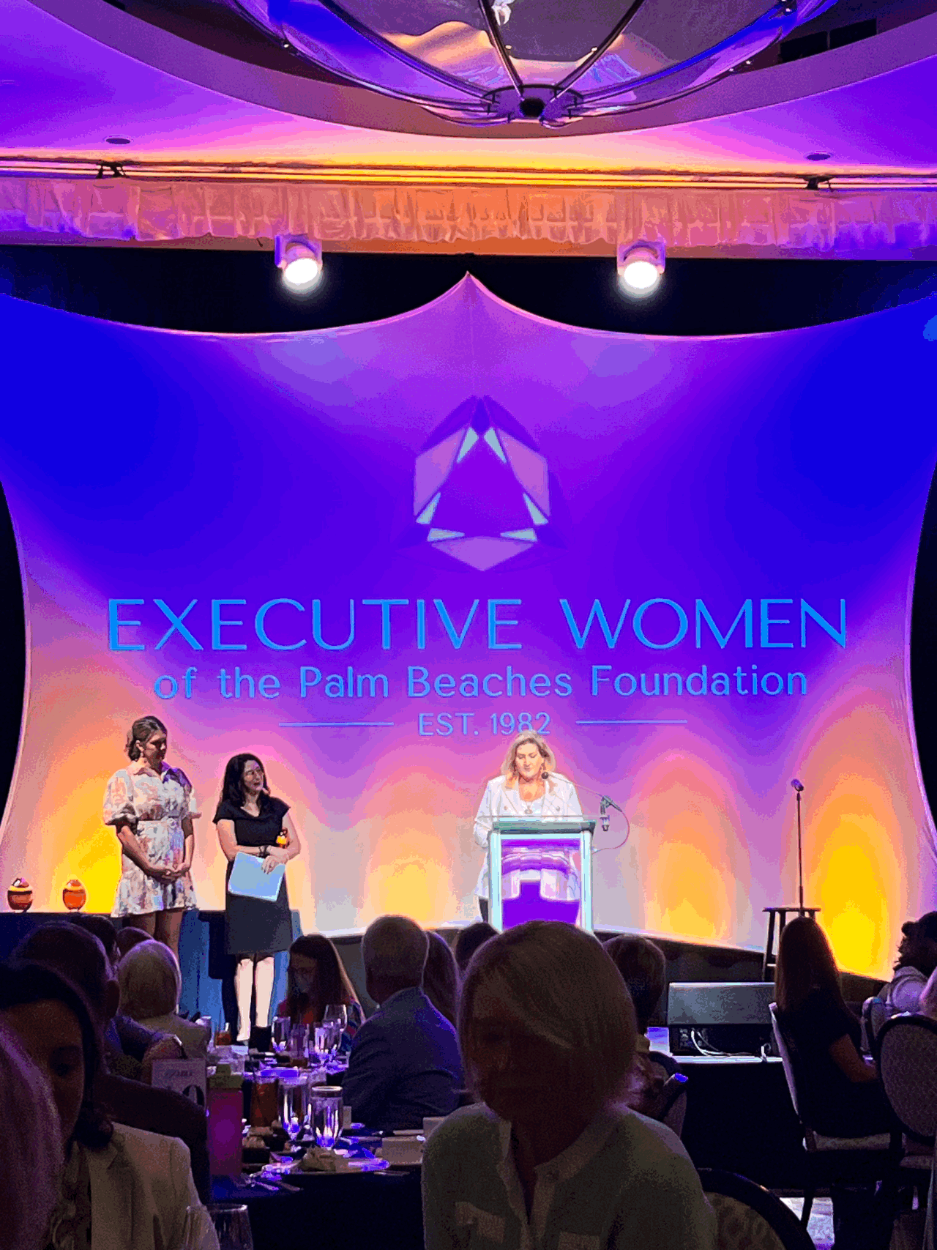
###
Note to editors: You are invited to interview a CareerSource spokesperson on local employment and economic trends. Please call 561.340.1060 ext. 2489 for scheduling before 3 p.m. today.
Note: The unemployment rate is a measure of how many people in the labor force are out of a job. For example, if total employment holds constant and unemployed Americans stop looking for work, thereby leaving the labor force, the unemployment rate will fall even though no jobs have been added. Conversely, if employment holds steady and recent graduates enter the labor force looking for work, the unemployment rate will rise even though no jobs have disappeared.

IN COMPLIANCE WITH THE STEVENS AMENDMENT:
CareerSource Palm Beach County, Inc. is the direct service provider for various workforce programs supported by the U.S. Departments of Labor, Health and Human Services, Education and other agencies as part of awards totaling $15,851,406 (revised annually). Unless otherwise stipulated, all statements, news releases, requests for proposals, bid solicitations and other applicable documents are fully funded from federal sources.

